**HoloBio** **User Guide**

**Table of contents**

**Introduction**

HoloBio-GUI is an open-source, Python-based graphical user interface designed to simplify the use of Digital Holographic Microscopy (DHM) for biological research. The software was developed to bridge the gap between advanced optics and biological applications, providing researchers with an intuitive platform to reconstruct, analyze, and quantify samples information without requiring programming expertise.

The software integrates two primary modes of operation: Real-Time Processing and Offline Processing. Real-Time Processing enables live reconstruction and analysis of holograms at video frame rates using a connected digital camera, while Offline Processing provides advanced numerical tools for the reconstruction of previously recorded holograms. Both modes are complemented by specialized packages for Digital Holographic Microscopy (DHM) and Digital Lensless Holographic Microscopy (DLHM), ensuring compatibility with a wide range of experimental configurations, including in-line, slightly off-axis, and off-axis setups.

This manual is designed to guide users through the functionalities of HoloBio, from installation and mode selection to advanced reconstruction and analysis procedures. Each section is structured to provide step-by-step instructions accompanied by graphical references, ensuring accessibility for both novice and experienced users. By following this manual, researchers can fully exploit the capabilities of HoloBio to obtain reliable, reproducible, and quantitative insights from holographic data in diverse biological applications.

1. **Installation Instructions**
2. **Main Menu**

Upon launch **HoloBio**, the **Main Menu** screen appears, providing access to all core processing modes **Fig. 1**. The interface is designed for quick navigation, allowing users to choose between real-time and offline hologram processing.

The main menu is divided into two packages:

* **Real-Time Hologram Processing** – For live acquisition and processing of holograms directly from a connected camera.
* **Offline Hologram Processing** – For processing previously recorded holograms from local storage.

In each processing mode, two options are available:

**DHM** (*Digital Holographic Microscopy*): Standard configuration for general DHM workflows.

**DLHM** (*Digital Lensless Holographic Microscopy*): Configuration for lensless holographic setups.

**Specifications packages**

* **Real-Time Hologram Processing**: This section grants access to real-time acquisition and visualization modules. By clicking either the **DHM** or **DLHM** button, the user is directed to the corresponding live-processing interface, optimized for immediate reconstruction of incoming holographic data from a connected camera. These modules are designed for responsive performance on standard laboratory hardware and are equipped with tools such as live phase visualization, Fourier inspection, and real-time filtering.
* **Offline Hologram Processing**: This section provides access to offline modules for the numerical reconstruction and analysis of previously acquired holograms. Users can load single images or video sequences and apply a variety of propagation and phase retrieval methods, depending on the chosen modality (DHM or DLHM). The interface dynamically adapts to support lens-based or lensless configurations, ensuring that relevant parameters and algorithms are presented contextually.

**How to Proceed:**

1. Choose between **Real-Time** or **Offline** processing based on your workflow.
2. Select **DHM** or **DLHM** depending on your microscopy configuration.
3. The application will open the corresponding processing interface.

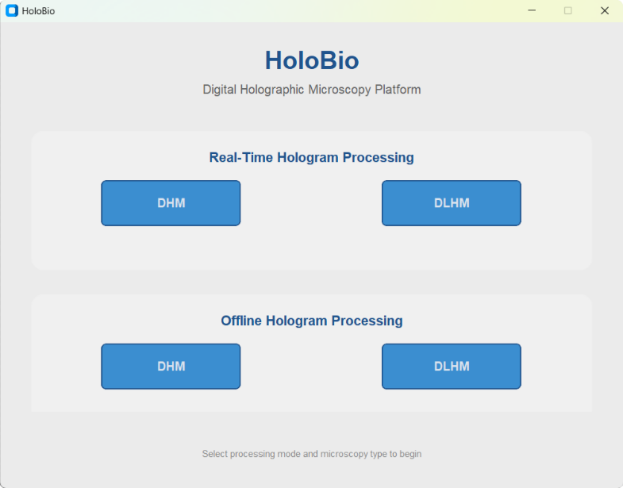

2

1

**Fig. 1**. Main menu of HoloBio, displaying the available processing modes (Real-Time and Offline) and microscopy configurations (DHM and DLHM).

1. **Common Interface Components**

**3.1 Main Control Panel**

The **Main Control Panel** is a common element to all the working modes located at the top of all HoloBio interfaces (see **Fig. 2**). It provides access to essential file management, analysis, and display settings, independent of the selected processing mode.

The panel contains the following menus and controls:

* **Load:** Opens hologram or sample images into the workspace. Available options include:
  + **Hologram** – Loads a single hologram image from local storage.
  + **Stack of Holograms** – Loads a sequence of holograms.
  + **Sample** – Loads a reference sample image for testing or demonstration purposes.
* **Tools:** Provides quick access to auxiliary processing and analysis modules:
  + **Bio-Analysis** – Opens the biological analysis suite for quantitative evaluation of reconstructed amplitude and phase images.
  + **Filters** – Grants access to spatial filtering tools for image enhancement and color map for visualizations.
  + **Speckle** – Opens the speckle noise measurement and reduction module.
* **Save:** Stores processed results in standard image formats. Options include:
  + **Save FT** – Saves the Fourier Transform representation of the hologram.
  + **Save Phase** – Saves the reconstructed phase image.
  + **Save Amplitude** – Saves the reconstructed amplitude image.
* **Theme:** Changes the visual appearance of the interface:
  + **Light** – Activates a light color scheme.
  + **Dark** – Activates a dark color scheme.

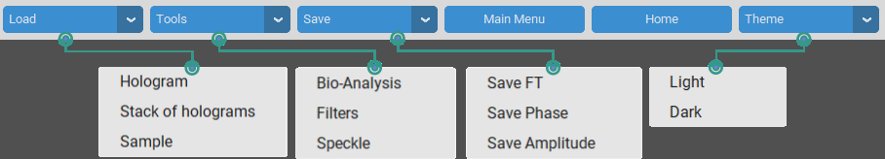

**Fig. 2.** Main menu bar of HoloBio with available tools and configuration options.

**3.2 Visualization Panel**

The Visualization Panel is the central display area of **HoloBio**, present in all processing modes **Fig. 3**. It is divided into two main windows that allow users to inspect the input hologram and its numerical reconstruction side by side.

* **Hologram / Fourier Transform Window (1):** Located on the left side, this window displays either the original hologram or its Fourier transform, depending on the selected option. A zoom control is available for detailed inspection of images.
* **Reconstruction Window (2):** Located on the right side, this window presents the numerical reconstruction of the hologram, which can be displayed either as a Phase Reconstruction or an Amplitude Reconstruction. A zoom control is also available to facilitate the evaluation of specific regions of interest.

Together, these two windows provide a synchronized workspace for comparing raw holographic data with its reconstructed representations, ensuring efficient analysis and interpretation.

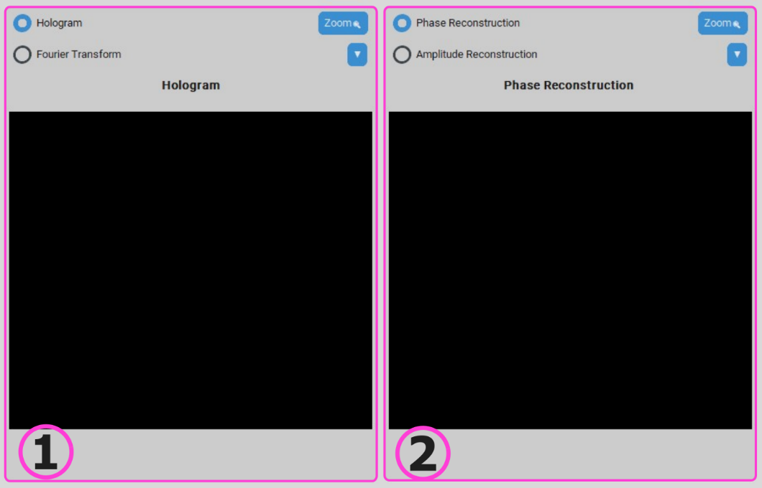

**Fig. 3.** Visualization panel of HoloBio showing (1) the hologram/Fourier transform display and (2) the phase or amplitude reconstruction display.

1. **Offline Hologram Processing**
   1. **Offline DHM**

Selecting the Offline DHM option in the Main Menu opens the interface shown in **Fig. 4**. This workspace is organized into three main components to facilitate hologram reconstruction and analysis workflows.

* **Main Control Panel (1)**: Located at the top of the interface, this panel contains the primary operational controls. It includes buttons for loading and saving datasets, accessing additional tool panels (Tools), returning to the main menu or home screen, and switching between available interface themes. For more details about its function, refer to the ***Common Interface Components*** section.
* **Processing Methods Panel (2):** Positioned on the left side of the window, this panel lists the available DHM processing methods: Phase Shifting, Phase Compensation, and Numerical Propagation. Selecting a method updates the control panel to display the corresponding parameters and tools relevant to the chosen process.
* **Visualization Panel (3):** Occupying the central and right sections of the interface, this panel provides the main display area for holographic data. It supports the visualization of the original hologram, or its Fourier transform on the left side, and either amplitude or phase reconstructions on the right side. For more details about its function, refer to the ***Common Interface Components*** section.

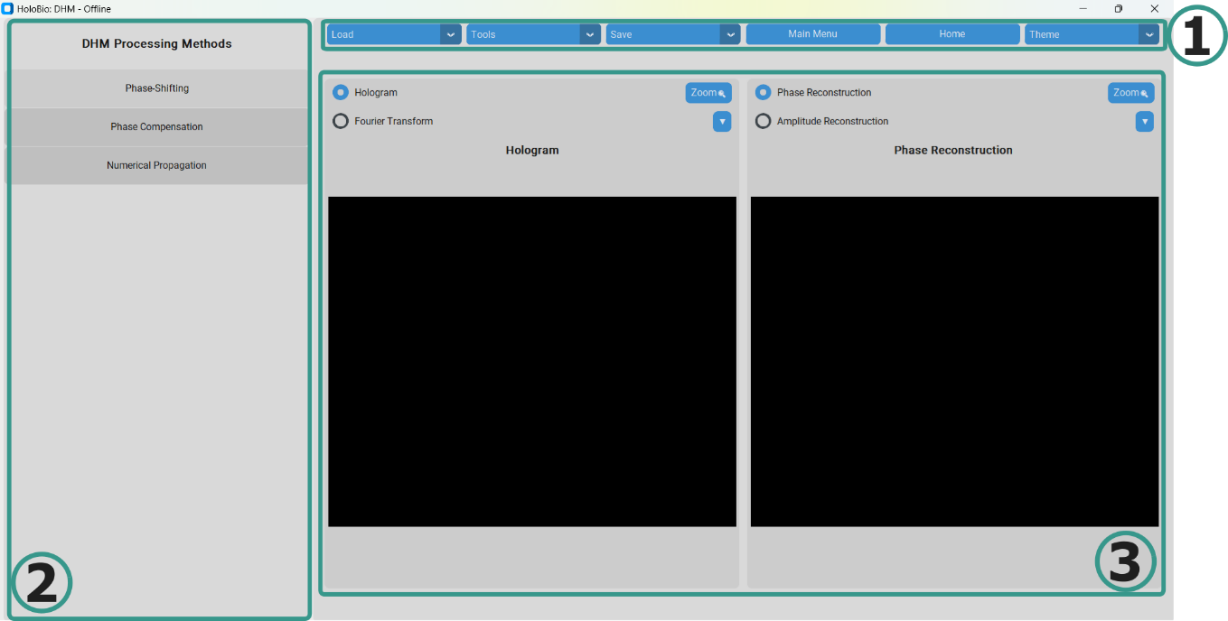

**Fig. 4**. HoloBio offline DHM interface with (1) main control panel, (2) processing methods section, and (3) dual visualization panel.

In the **Offline DHM** module, the **Processing Methods Panel** (Panel 2) dynamically updates to display the controls and parameters relevant to the selected reconstruction method. The three available methods, *Phase Compensation*, *Phase Shifting*, and *Numerical Propagation*, each present a distinct set of options tailored to their respective workflows, see **Fig. 5**.When a method is selected, the panel adapts to provide: Method-specific configuration options, input fields for relevant optical system parameters, and controls for propagation settings and reconstruction output.

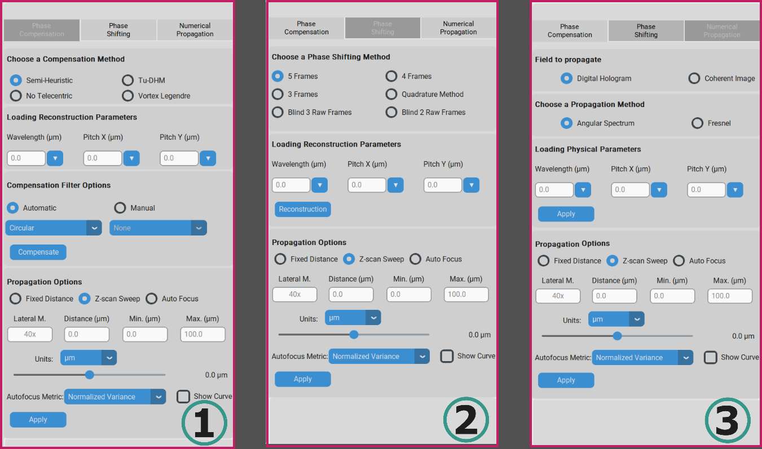

**Fig. 5.** Detailed configuration menus in the Processing Methods Panel: (1) Phase Compensation, (2) Phase Shifting, and (3) Numerical Propagation.

* + 1. **Phase Compensation**

When the *Phase Compensation* method is selected in the **Offline DHM** module, the **Processing Methods Panel** is updated with controls specific to off-axis phase reconstruction (**Fig. 6** panel 2). This method is designed for numerical reconstruction of holograms recorded in off-axis architecture.

The panel contains the following sections:

* **Choose a Compensation Method:** Offers multiple algorithmic approaches for phase compensation: *Semi-Heuristic*, *Tu-DHM*, *No Telecentric*, and *Vortex Legendre*. Each method implements a distinct compensation strategy tailored to specific optical configurations and aberration characteristics. Additional details about these approaches can be found in the **Appendix** section.
* **Loading Reconstruction Parameters:** Allows input of essential optical parameters:
  + **Wavelength** - Specifies the wavelength of the light source used during hologram acquisition.
  + **Pitch X** and **Pitch Y** - pixel size of the digital camera used during hologram acquisition.
* **Compensation Filter Options:** Provides the choice between *Automatic* and *Manual* spatial filtering.
  + **Automatic** – Applies a predefined filter shape centered on the detected diffraction order between **Circular** and **Rectangle.**
  + **Manual** – Enables user-defined placement and adjustment of the filter. This mode offers greater control over size, position, and shape. Available options include: **None**, **Circular Coordinates, Circular Manual**, **Rectangle Coordinates, Rectangle Manual,** **Non-Telecentric Coordinates,** and **Non-Telecentric Manual.**
* **Propagation Options:** Defines how the compensated complex field is propagated:
  + Modes: **Fixed Distance**, **Z-scan Sweep**, or **Auto Focus**.
  + Adjustable parameters: *Lateral Magnification*, *Distance*, *Min* and *Max* range, and propagation units.
  + Autofocus metric selection and optional visualization of the focus curve.

The rest of the interface remains consistent, with the **Main Control Panel** (Panel 1) available for general operations and the **Visualization Panel** (Panel 3) displaying either the hologram/Fourier transform (left) or the amplitude/phase reconstruction (right).

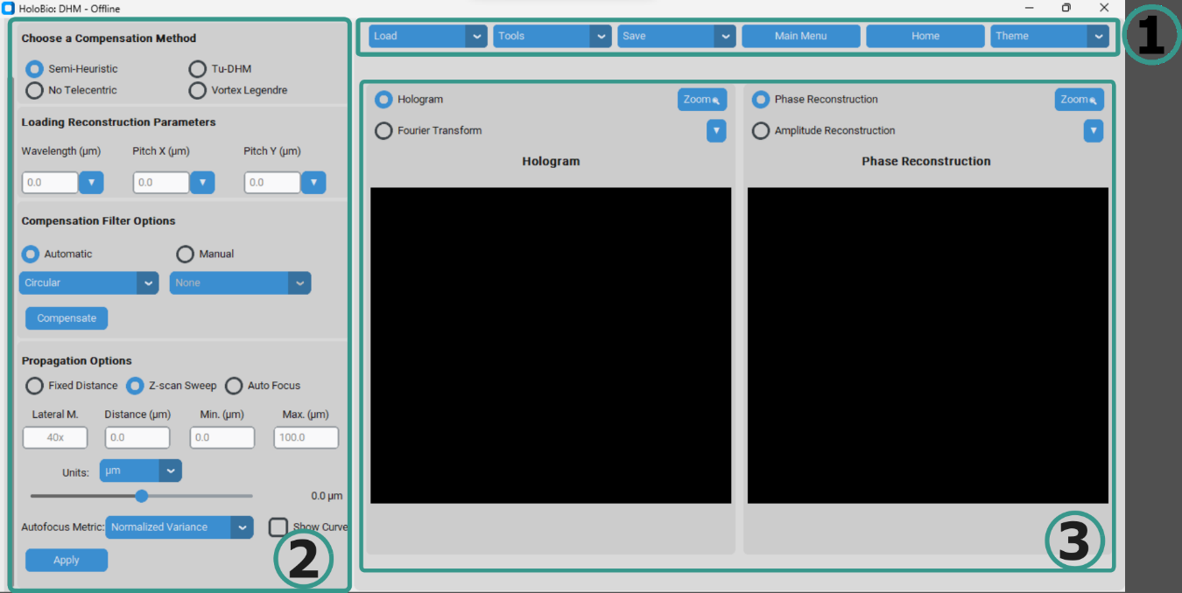

**Fig. 6.** Phase Compensation method displayed in the Offline DHM interface of HoloBio.

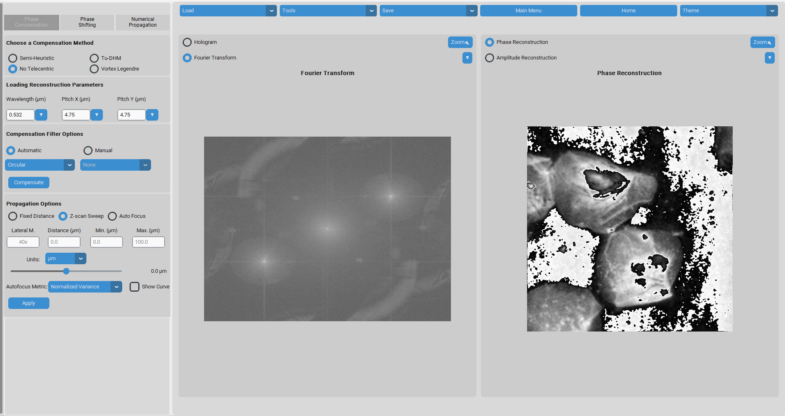

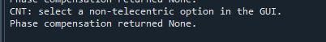

**Is this normal?**

**When the compensation is been sone user does not know if its running or if something went wrong, maybe consider add a progress bar or something like that**

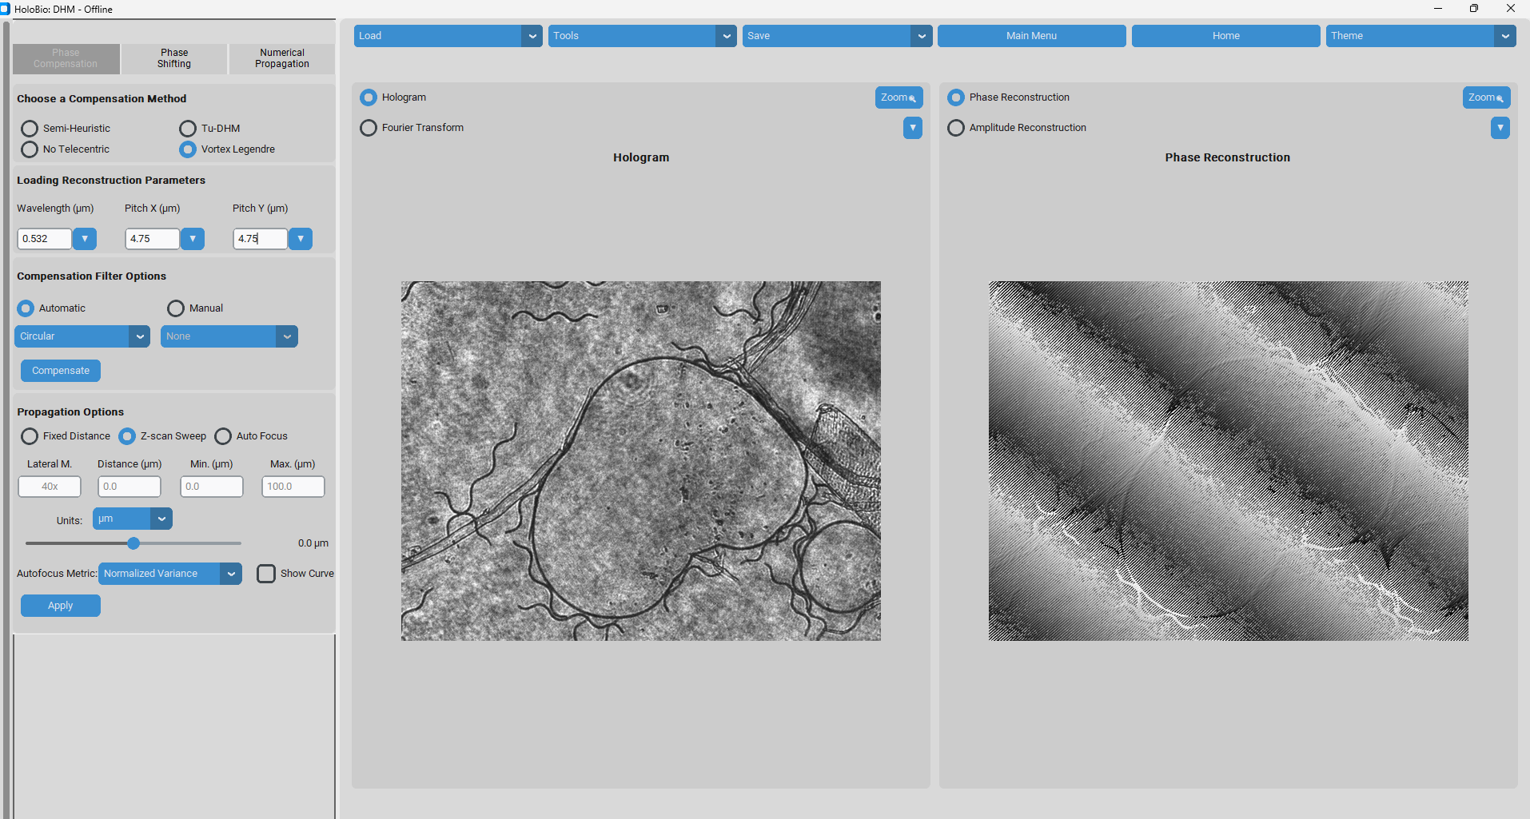

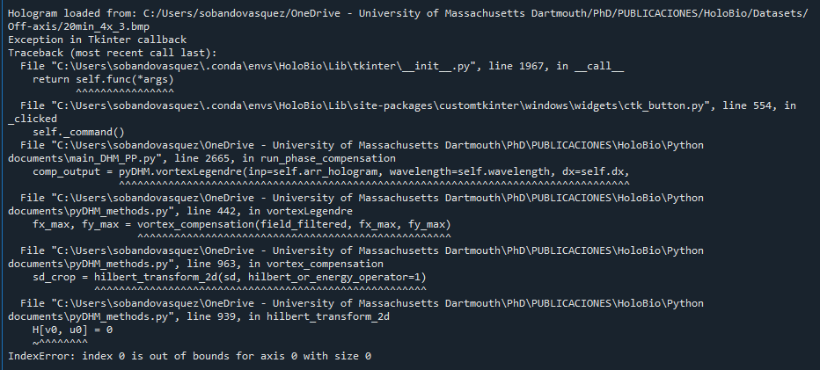

**I think something went wrong for this image in the vortex, but I don’t know why.**

**What is suppose to happen when the user select the manual compensation? Because I did it and I don’t know how to “draw” or enter the coordinates**

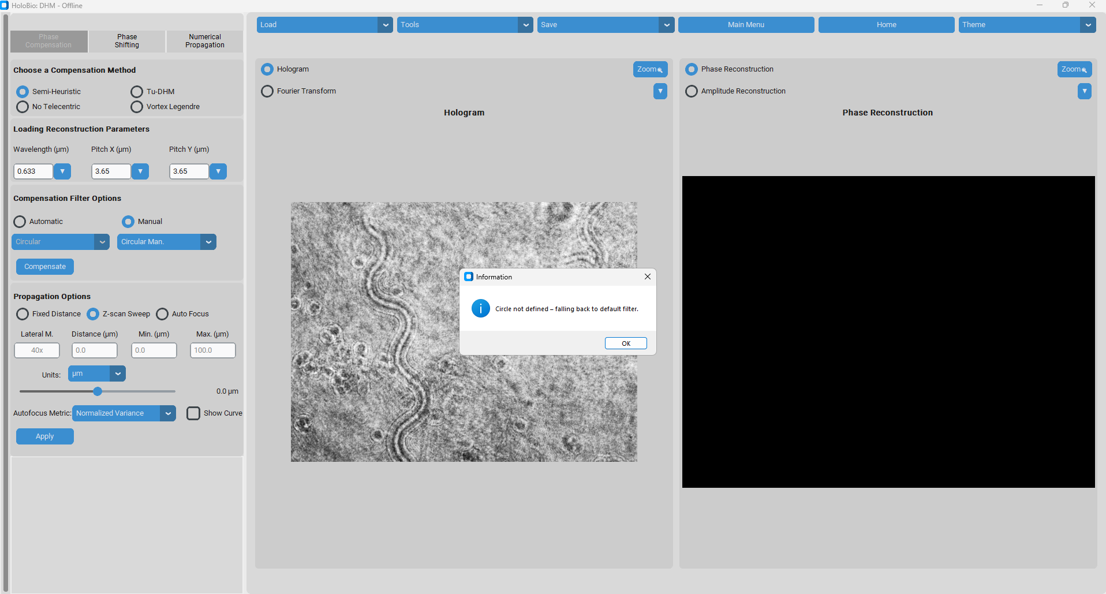

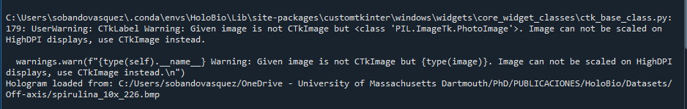

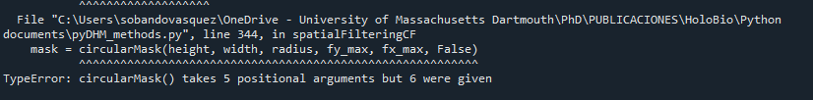

**User cannot see the coordinates when the dialog window is open**

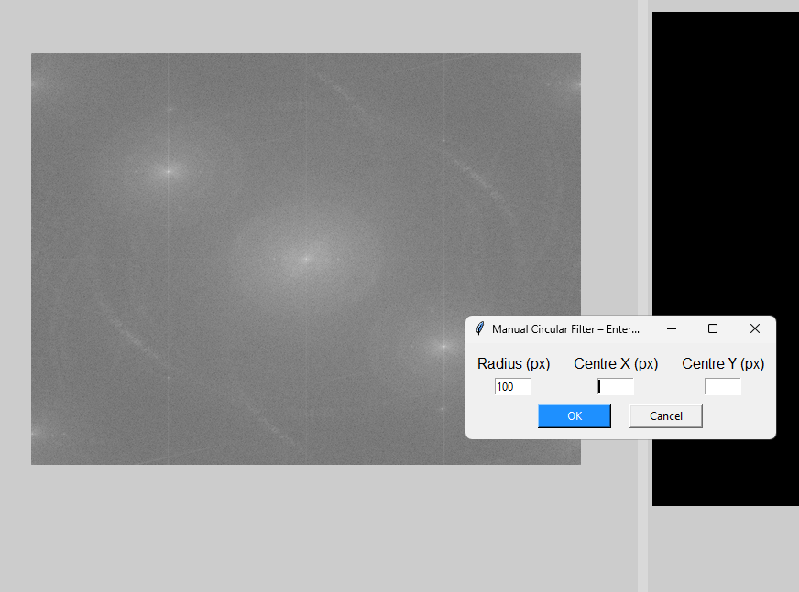

**Manual setting for spatial filtering is not working properly**

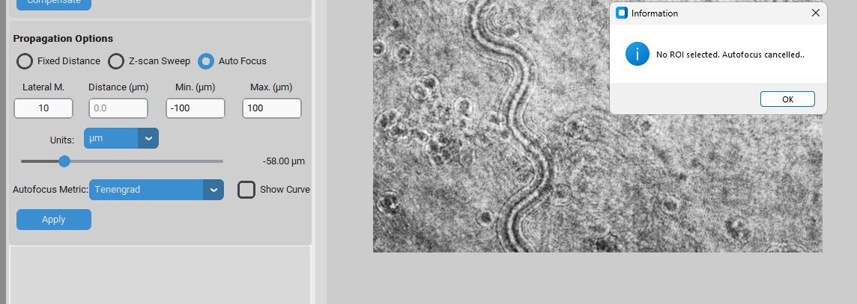

**What ROI? I was not asked for selecting any ROI**

**When the user select a Z-scan Sweep which size is the step? Is always the same? Why is not chosen by user?**

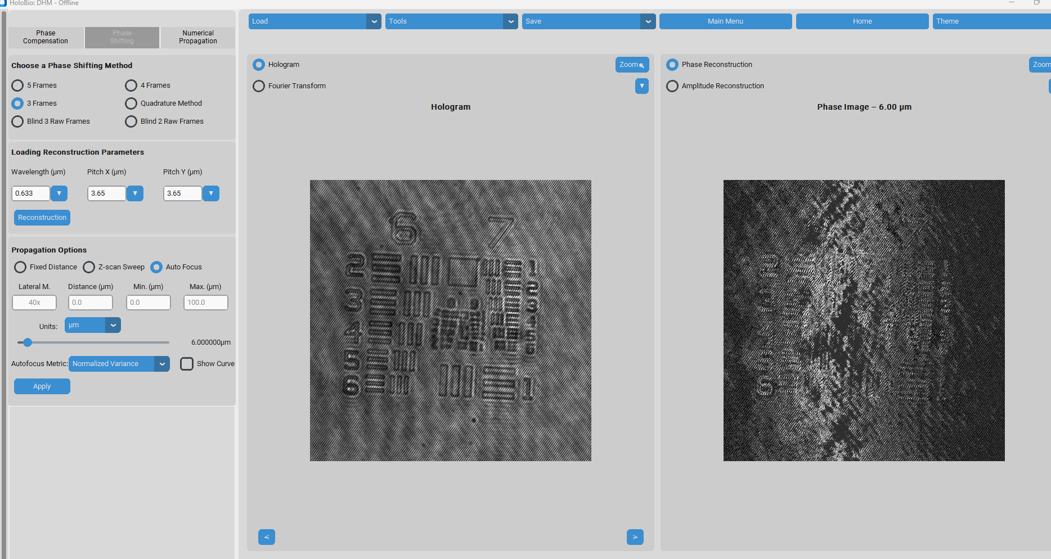

**I was playing with the app with DHM holograms, and then I change to ohase shifting, but the propagation setup did not went back to default, and now the visualization of the phase is weird, because its at a random distance, todos los paneles deberian Volver a valores predeterminados cuando el usuario cambia de tipo de reconstruccion, sino tocaria cerrar y Volver a abrir**

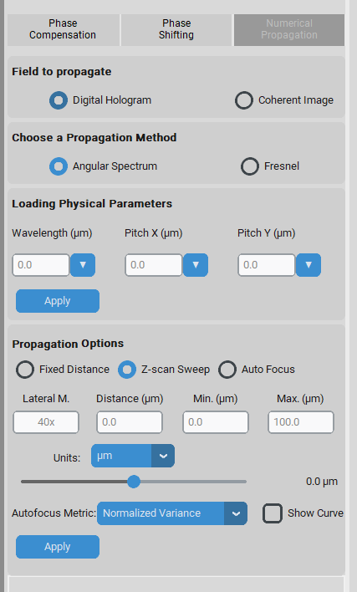

**Que es coherent image en este contexto?**

**How to use it?**

Step 1 – Load a hologram.

Step 2 – Choose a compensation method.

Step 3 – Define reconstruction parameters.

Step 4 – Configure the compensation filter.

Step 5 – Run compensation.

**Practical Example: Offline DHM / Phase Compensation**

To illustrate the use of the Phase Compensation method in the Offline DHM module, **Fig. 7** shows the reconstruction of red blood cells. The hologram was acquired in an off-axis configuration and reconstructed using the **Semi-Heuristic compensation method**. The following parameters were defined in the **Loading Reconstruction Parameters** panel: wavelength λ = 633 nm and camera pixel size = 3.75 µm in both X and Y directions. In the **Compensation Filter Options**, the **Automatic Circular filter** was selected to isolate the +1 diffraction order in the Fourier plane. After pressing **Compensate**, the system reconstructed the phase information of the sample. Fig. 7 displays the recorded hologram as loaded into the interface. Also presents the corresponding **Phase Reconstruction**, where the morphology of individual red blood cells is clearly visible.

This example highlights how the Phase Compensation method enables the quantitative visualization of transparent biological samples such as red blood cells, allowing detailed morphological analysis directly from off-axis holograms.

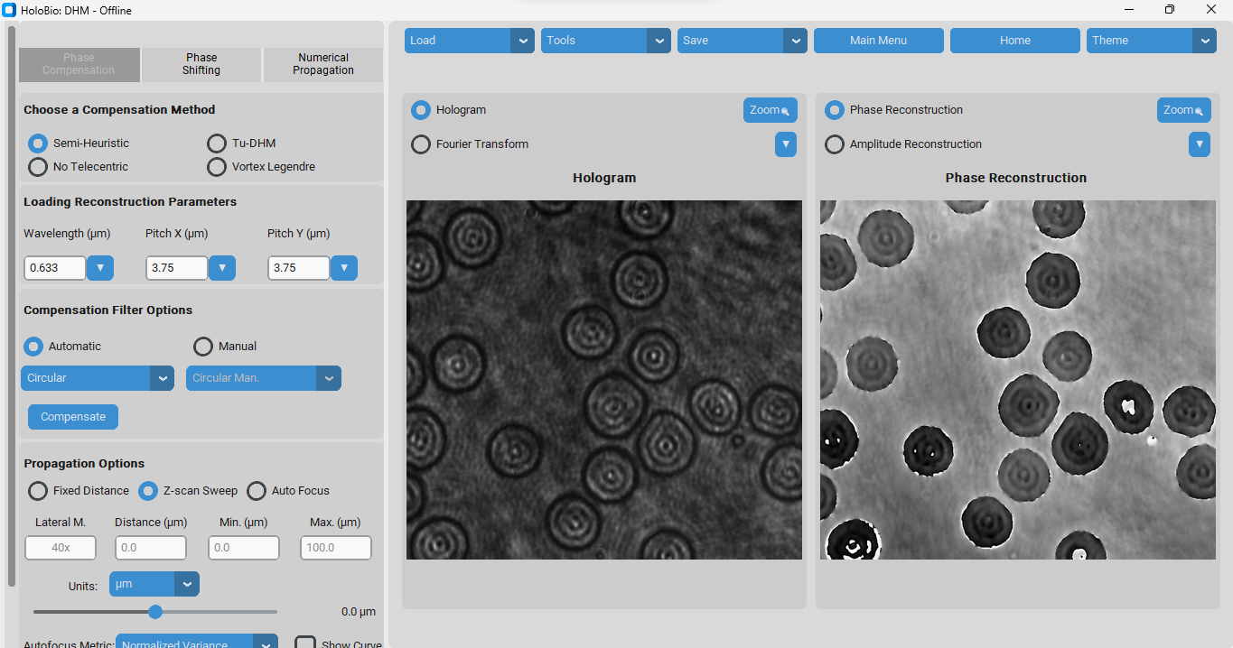

**Fig. 7.** Offline DHM interface showing the Phase Compensation method applied to red blood cells.

* + 1. **Phase Shifting**

When the *Phase Shifting* method is selected in the **Offline DHM** module, the **Processing Methods Panel** is updated with controls specific to phase-shifting reconstruction workflows (Fig 7). This method is intended for the numerical recovery of holograms acquired in both in-line and slightly off-axis configurations.

The panel includes the following sections:

* **Choose a Phase Shifting Method:** Provides radio-button options to select the acquisition scheme used for phase-shifting holograms. Available configurations include *5 Frames*, *4 Frames*, *3 Frames*, *Quadrature Method*, *Blind 3 Raw Frames*, and *Blind 2 Raw Frames*.
* **Loading Reconstruction Parameters:** Allows input of key system parameters required for phase reconstruction.
  + **Wavelength** - Specifies the wavelength of the light source used during hologram acquisition.
  + **Pitch X** and **Pitch Y** -pixel size of the digital camera used during hologram acquisition.  
    Once parameters are set, the **Reconstruction** button initiates the computation.
* **Propagation Options:** Controls the numerical propagation of the reconstructed field:
  + **Fixed Distance**, **Z-scan Sweep**, or **Auto Focus** modes.
  + **Lateral Magnification** and propagation distance ranges (*Min* and *Max*) can be specified, with selectable units.
  + An **Autofocus Metric** can be selected (e.g., *Normalized Variance*), with the option to display the focus curve.
  + The **Apply** button executes the propagation with the chosen settings.

The rest of the interface remains unchanged, with the **Main Control Panel** (Panel 1) providing access to general commands and the **Visualization Panel** (Panel 3) displaying the loaded hologram or its Fourier transform (left) and the resulting amplitude or phase reconstruction (right).

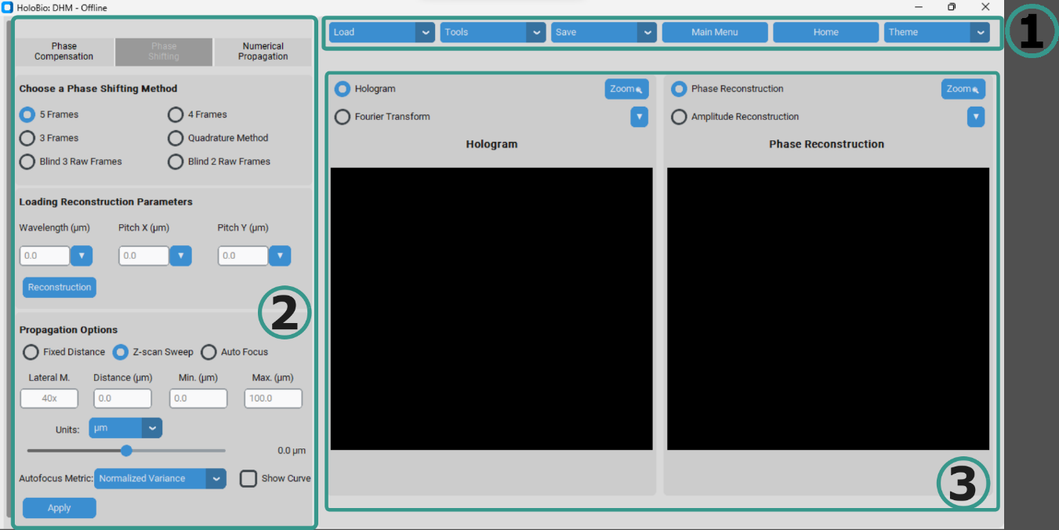

**Fig 8.** Phase Shifting method displayed in the Offline DHM interface of HoloBio.

**How to use it?**

Step 1 – Load a set of holograms.

Step 2 – Choose a phase shifting method.

Step 3 – Define reconstruction parameters.

Step 4 – Configure the compensation filter.

Step 5 – Run compensation.

**Practical Example: Offline DHM / Phase Shifting Compensation**

To demonstrate the use of the Phase Shifting method in the Offline DHM module, Fig. 9 shows the reconstruction of a QPI target from Benchmark Technologies, used to characterize the optical performance of the experimental DHM setup. The hologram was acquired with a green laser source at λ = 532 nm and a digital camera with a pixel size of 2.4 µm. In the Choose a Phase Shifting Method section, the **Blind 2 Frames option** was selected. The reconstruction parameters (wavelength and pixel size) were entered in the Loading Reconstruction Parameters panel. Fig. 9 presents the recorded hologram of the QPI target. After applying the Phase Shifting reconstruction, the displays the Phase Reconstruction, where the resolution patterns and calibrated structures of the target are clearly visible.

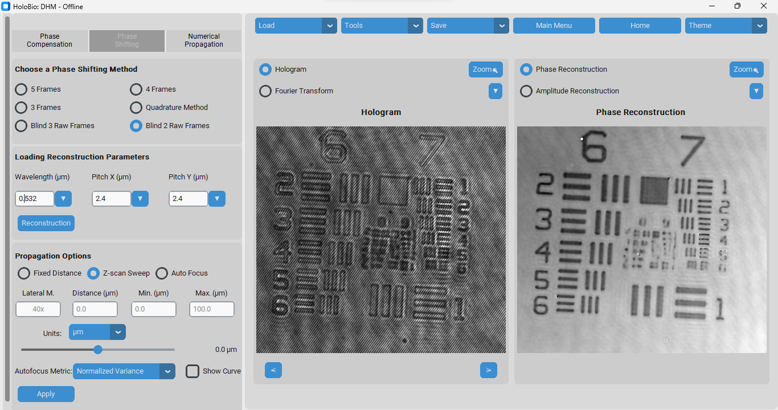

**Fig 9.** Phase Shifting method displayed in the Offline DHM interface of HoloBio.

**4.1.4 Numerical Propagation**

When the **Numerical Propagation** method is selected in the Offline DHM module, the Processing Methods Panel is updated with controls designed for the propagation of digital holograms or coherent images (**Fig. 10**). This method is intended for numerical reconstruction of optical fields.

The panel includes the following sections:

* **Field to propagate:** Users can select whether to propagate a Digital Hologram (raw interference pattern) or a Coherent Image (previously reconstructed field).
* **Choose a Propagation Method:** Provides radio-button options to select the algorithm used for propagation. Available configurations include **Angular Spectrum** and **Fresnel**.
* **Loading Physical Parameters:** Allows the user to define key acquisition values:
  + Wavelength (λ): wavelength of the illumination source.
  + Pitch X and Pitch Y: pixel size of the digital camera in each axis.
* **Propagation Options:** Determines how the optical field is numerically propagated:
  + Fixed Distance, Z-scan Sweep, or Auto Focus modes.
  + Additional parameters include Lateral Magnification, Distance, Min/Max range, and selectable Units (e.g., µm).
  + An Autofocus Metric can be chosen (e.g., Normalized Variance), with the option to enable Show Curve for visualization of the focus evaluation.
* **Apply button:** Executes the numerical propagation with the chosen configuration.

The rest of the interface remains consistent, with the Main Control Panel (Panel 1) available for general operations and the Visualization Panel (Panel 3) displaying either the loaded hologram/Fourier transform (left) or the corresponding amplitude/phase reconstruction (right).

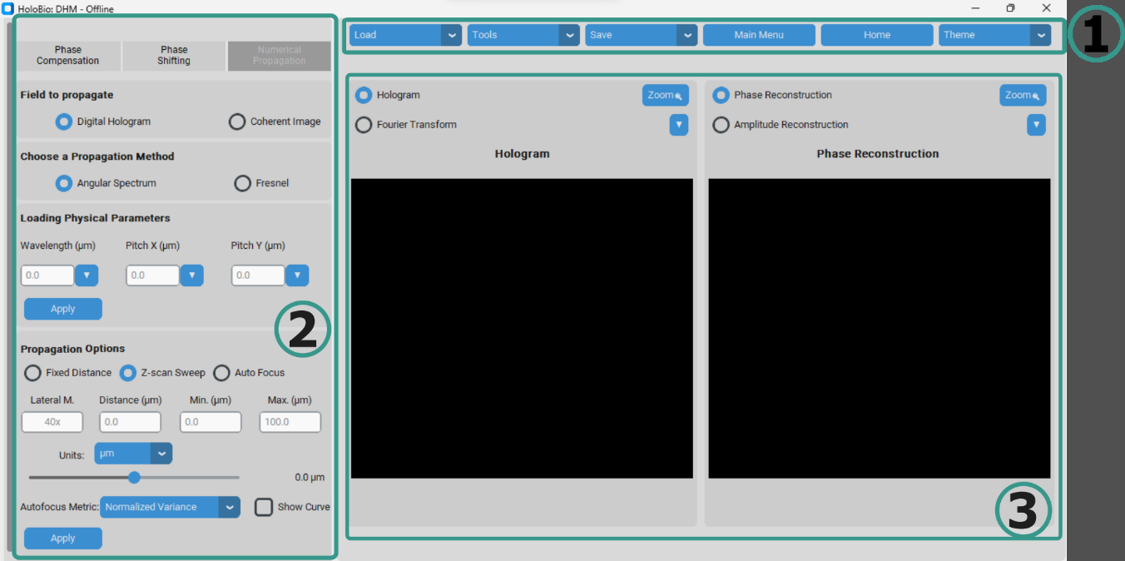

**Fig. 10.** Numerical Propagation method displayed in the Offline DHM interface of HoloBio.

**How to use it?**

Step 1 – Load an Image.

Step 2 – Choose the field to propagate.

Step 3 – Define the propagation method.

Step 4 – Configure the physical parameters.

Step 5 – Define the propagation options.

Step 6 – Run the propagation.

**Practical Example: Offline DHM / Numerical Propagation**

To demonstrate the use of the Numerical Propagation method in the Offline DHM module, **Fig. 11** shows the propagation of a simulated coherent image designed to evaluate diffraction patterns. In this case, the Angular Spectrum method was selected. The input parameters included a laser wavelength of λ = 532 nm and a camera pixel size of 6.5 µm. In the Propagation Options panel, the Fixed distance mode was enabled, with a value of 5000 µm. **Fig. 11** presents the coherent image used as the input field. After applying the Angular Spectrum propagation, the displays the resulting Ampliude Reconstruction, where the diffraction rings and interference structures characteristic of coherent illumination are clearly resolved.

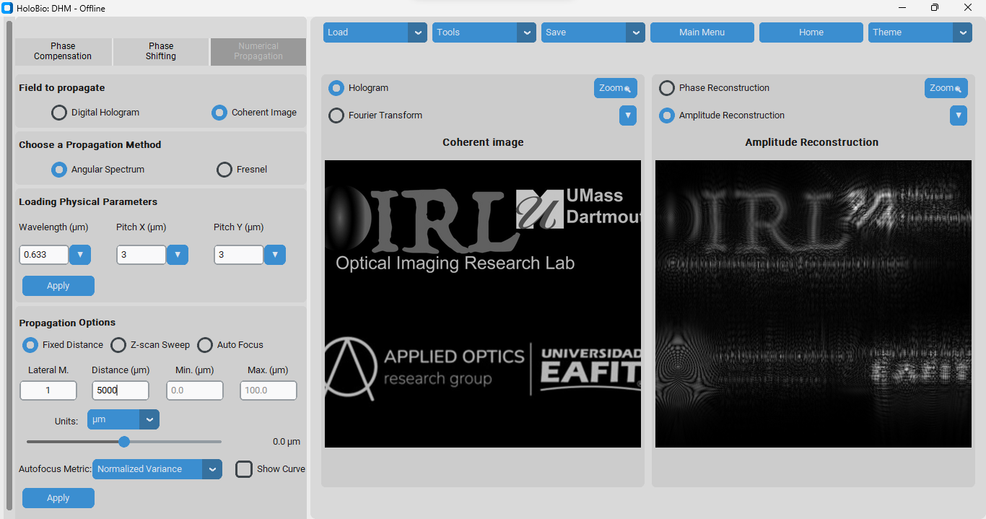

**Fig. 11.** Offline DHM interface using the Numerical Propagation module.

**4.1.5 Propagation Option**

The Propagation Options panel allows users to numerically propagate the reconstructed optical field by choosing among different modes (Fixed Distance, Z-scan Sweep, and Auto Focus). This tool is shared across the Phase Compensation, Phase Shifting, and Numerical Propagation modules.

* **Fixed Distance**: Reconstructs the field at a single specified axial distance.
* **Z-scan Sweep:** Propagates the field across a range of distances defined by Min and Max, generating multiple propagations.
* **Auto Focus:** Automatically finds the optimal focus plane using a selected sharpness metric (Normalized Variance, Tenengrand).

**Input Parameters:**

* **Lateral Magnification:** Defines the optical magnification used during acquisition of the hologram (e.g., 40x).
* **Distance (µm):** Indicates the numerical propagation distance when using Fixed Distance mode.
* **Min (µm) / Max (µm):** Specify the lower and upper bounds of the axial range for the Z-scan Sweep.
* **Units:** Allows the user to select the unit system for distance (e.g., µm).
* **Show Curve:** Displays the sharpness metric curve across the scanned range, helping the user visualize and confirm the selected focal plane.

**How to use it?**

* 1. **Fixed Distance**

Step 1 – Select the Fixed Distance option in the Propagation panel.

Step 2 – Enter the Lateral Magnification of the optical system (e.g., 40x).

Step 3 – Specify the Propagation Distance at which you want to reconstruct the field.

Step 4 – Click Apply. The software will generate the numerical reconstruction of the optical field at the selected distance.

* 1. **Z-scan Sweep**

Step 1 – Select the Z-scan Sweep option in the Propagation panel.

Step 2 – Enter the Lateral Magnification of the system.

Step 3 – Define the Min and Max distances to establish the axial scanning range.

Step 4 – Click Apply. The system will propagate the field across the specified range.

Step 5 – Use the slider bar to browse through the reconstructed fields.

* 1. **Auto Focus**

Step 1 – Select the Auto Focus option in the Propagation panel.

Step 2 – Enter the Lateral Magnification of the system.

Step 3 – Define the Minimum (µm) and Maximum (µm) distances that set the axial range where autofocus will be evaluated.

Step 4 – Choose a Sharpness Metric (e.g., Normalized Variance or Tenengrad).

Step 5 – (Optional) Select Show Curve if you wish to display the sharpness metric across the scanned range.

Step 6 – Click Apply. An image will appear prompting you to select the Region of Interest (ROI) where autofocus should be evaluated. The software will then calculate and display the optimal focal plane.

* 1. **Offline DLHM**

**4.2.1 Overview of the Offline DLHM Workspace**

Selecting the **Offline DLHM** option in the Main Menu opens the interface shown in **Fig. 12**. This workspace is structured into three main components that support reconstruction under the DLHM framework.

* **Parameters Panel (1):** Located on the left side of the interface, this panel provides input fields and sliders for defining the physical parameters of the reconstruction process. Users can configure wavelength, pixel pitch (X and Y), magnification, and distances between system components (camera-source distance *L*, sample distance *Z*, and reconstruction distance *r*). Additional options allow the selection of algorithms (Angular Spectrum, Kreuzer Method, DLHM) and setting global bounds for distance values.
* **Main Control Panel (2):** Positioned at the top of the interface, this toolbar centralizes key actions. It includes options to load holograms, access auxiliary tools, save results (Fourier Transform, phase, or amplitude reconstructions), return to the main menu or home screen, and switch interface themes.
* **Visualization Panel (3):** Occupying the central and right sections of the workspace, this panel serves as the main display area. On the left side, users can toggle between the hologram view and its Fourier transform. On the right side, users can select either phase or amplitude reconstructions. Zoom functions are available in both visualization windows, enabling detailed inspection of holographic data.

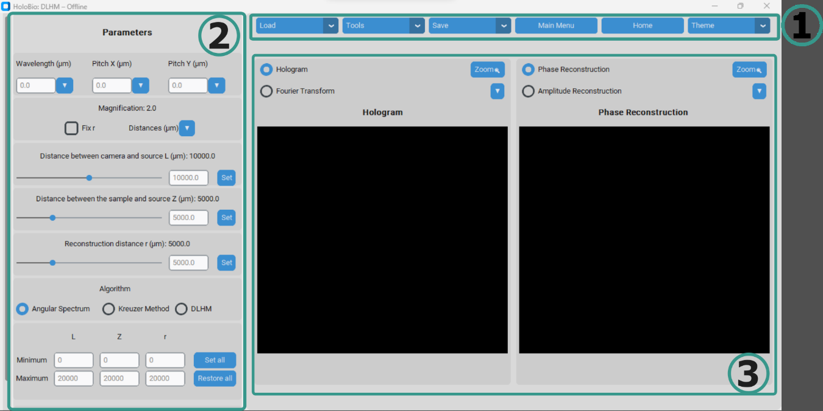

**Fig. 12.** Offline DLHM method displayed in the interface of HoloBio.

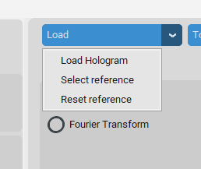

**How to use it?**

Step 1 – Load data.

Step 2 – Define physical parameters (Parameters Panel).

Step 3 – Choose reconstruction method.

Step 5 – Run reconstruction 🡪 Click on **Reconstruction button**. In the **Visualization Panel**, use the left window to review the **Hologram/FT** and the right window to toggle between **Amplitude** and **Phase**.

**Practical Example: Offline DLHM Reconstruction**

To illustrate the use of the Offline DLHM module, **Fig. 13** presents the reconstruction of *Paramecia* swimming in water, obtained from a previously recorded hologram. The reconstruction was performed using the **Kreuzer Method**, with the following parameters: wavelength λ = 532 nm, pixel size = 6.9 µm in both axes, and source-to-camera distance L = 20 mm. The source-to-sample distance was set to Z = 6.8 mm, corresponding to the focal plane of the middle paramecia. **Fig 13.** shows the Offline DLHM interface, where users specify key parameters such as wavelength, pixel pitch, and reconstruction distances, as well as choose the reconstruction algorithm. The Figure displays the original hologram recorded from the sample, and presents the amplitude reconstruction obtained at the selected propagation distance.

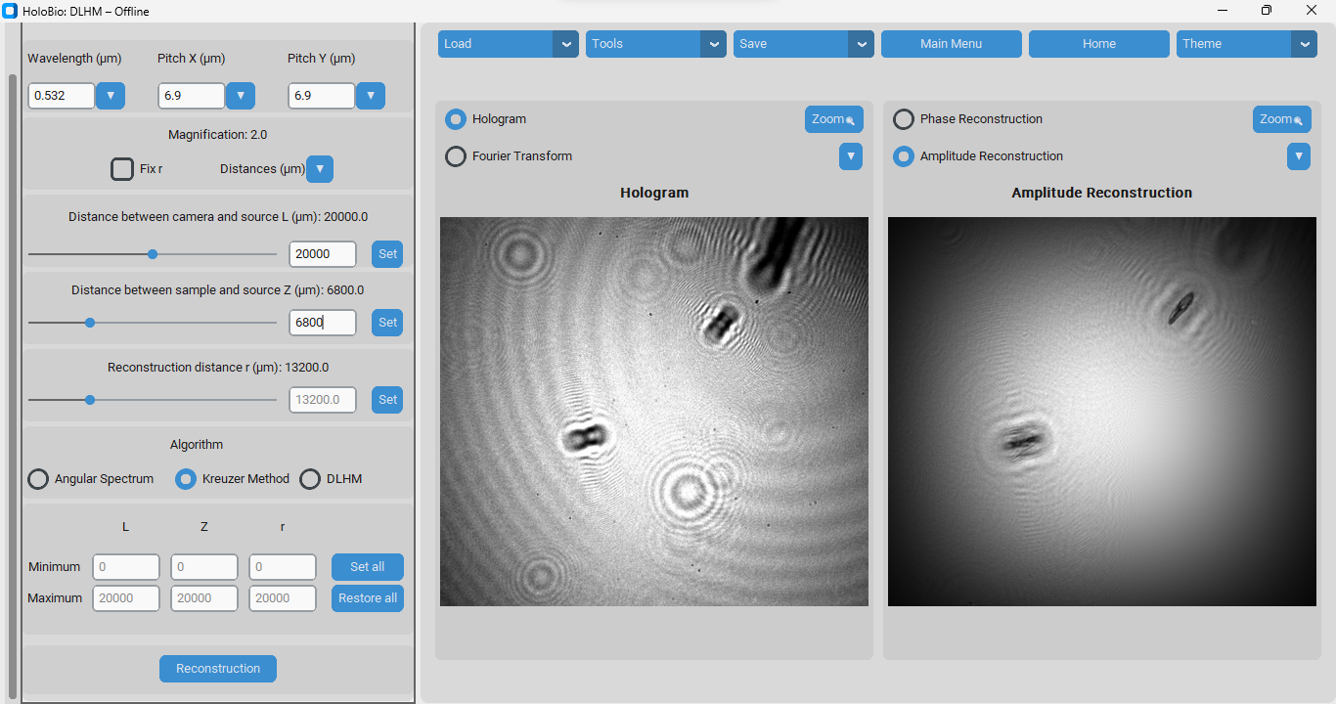

**Fig. 13.** Offline DLHM method displayed in the interface of HoloBio.

1. **Real-Time Hologram Processing**
   1. **Real-Time DHM**

Selecting the Real-time DHM option in the Main Menu opens the interface shown in 14. This workspace is designed to support the live acquisition and real-time reconstruction of holograms recorded in off-axis and telecentric architectures [REF], using a connected camera. It is organized into three main components that facilitate dynamic phase compensation, visualization, and particle tracking workflows:

* **Main Control Panel (1):** Located at the top of the interface, this panel contains the primary operational controls. For more details about its function, refer to the ***Common Interface Components*** section.
* **Processing and Control Panel (2):** Positioned on the left side of the window, this panel includes all the controls required for real-time operation. It is divided into functional sections:
  + **Parameters:** Input fields for wavelength and camera pixel pitches (X and Y).
  + **FT Visualization Options:** Selection of spatial filter geometry and toggles for viewing filtered or unfiltered Fourier transforms.
  + **Compensation Controls:** Buttons to start phase compensation and manage playback (Play/Stop).
  + **Record Options:** Controls to record videos of hologram, amplitude or phase reconstructions in real time.
  + **Particle Tracking:** Tools for tracking micro-particles, including filter selection, area thresholds, Kalman filter parameters, color filtering, and magnification options.
* **Visualization Panel (3):** Occupying the central and right sections of the interface, this panel provides two synchronized display windows. For more details about its function, refer to the ***Common Interface Components*** section.

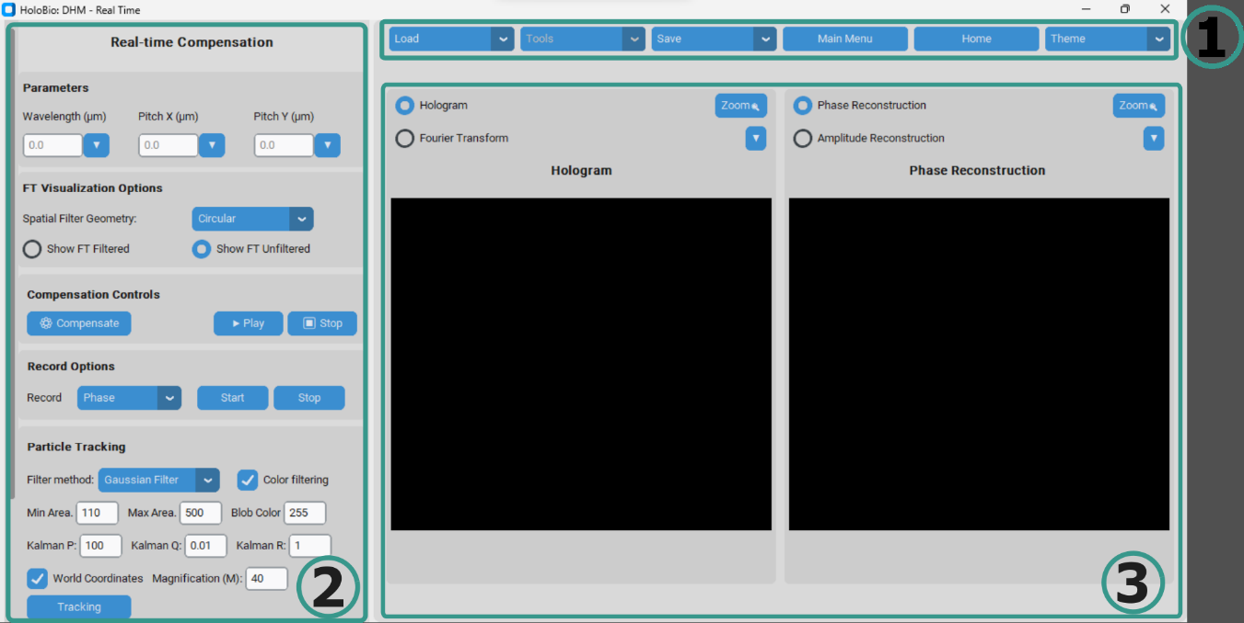

**Fig 14.** Real-Time DHM workspace with compensation controls, recording and tracking options (2), and the hologram/phase reconstruction visualization panels (3).

**5.1.1 Compensation of Holograms from Digital Camera**

This option enables the user to perform phase compensation on holograms acquired directly from a digital camera connected to the computer. To initialize the acquisition, click **Load > Init Camera**. The system will automatically detect the available camera and establish the connection for real-time hologram capture. Once the camera is active, the user can input the required reconstruction parameters (e.g., wavelength and pixel pitch) and press the Compensate button to initiate phase compensation.

During this process, the hologram is continuously captured from the live camera feed and processed in real-time, allowing immediate visualization and adjustment of parameters as needed.

**Note:** Ensure that the digital camera drivers are correctly installed on the computer prior to use. Proper installation of the manufacturer’s drivers is necessary for **HoloBio** to recognize the camera and establish a stable connection.

**5.1.2 Compensation for Previously Recorded Holograms**

This option allows the user to perform phase compensation on holograms acquired previously and stored as video files. To begin, click **Load > Load Video**, then select the desired hologram video from local storage. Once the video is loaded, the user must enter the reconstruction parameters (e.g., wavelength, pixel pitch) and press the Compensate button to start the phase compensation process.

When working with recorded holograms, the system provides several playback options that can be useful before initiating the compensation:

* **Play:** Starts video playback without applying any compensation. This is useful for previewing the content and identifying the region or frame of interest.
* **Pause:** Temporarily halts playback. This feature enables the user to stop at a specific frame and begin compensation from that point.
* **Stop:** Completely terminates the playback. If the Stop button is pressed, the video must be reloaded before compensation can be applied.

**5.1.2.1 Particle Tracking**

The Particle Tracking module enables the detection and trajectory analysis of particles over time from video sequences. This tool can be applied to videos of reconstructed Phase, Amplitude, or even directly to the original Hologram. To begin, the user must load the desired video by clicking **Load > Load Video**, complete the required parameters in the **Particle Tracking Panel**, and press Tracking to start the process.

The **Particle Tracking** tool combines filtering options, size constraints, and Kalman filter parameters to ensure accurate trajectory estimation.

* **Filter Method:** Provides two options to reduce background noise (speckle).
* **Gaussian Filter:** Reduces high-frequency noise and softens edges, but may blur contours.
  + **Bilateral Filter:** Smooths noise while preserving sharp edges; more computationally expensive but better suited for samples with fine details.
* **Color Filtering:** When enabled, the user must specify the polarity of the objects relative to the background by setting the **Blob Color**. Use **0** if the background is light and the particles are dark, or **255** if the background is dark and the particles are light.
* **Min Area / Max Area:** Define the size range (in pixels) for valid particles. Only objects within this range will be detected and tracked.
* **Kalman Filter Parameters:** Control the behavior of the tracking algorithm by modeling system and measurement uncertainties.
* **P (State Covariance):** Initial uncertainty in particle positions. High values make the filter adapt quickly to new measurements; low values make it trust the initial state.
* **Q (Process Noise):** Models irregularities in particle motion. High values allow adaptation to rapid or erratic movement; low values assume smooth trajectories.
* **R (Measurement Noise):** Represents detection uncertainty. High values make the filter rely more on predictions; low values make it follow measurements closely.
* **World Coordinates:** If enabled, particle positions are reported in real-world units instead of pixels.
* **Magnification (M):** Defines the optical magnification used during acquisition (e.g., 40x).

**Practical Recommendation:**

* Use moderately high values (e.g., P = 100 - 400) unless the initial particle positions are known with high certainty.
* Use a higher Q when tracking particles in turbulent environments or with irregular motion. And use a lower Q for smooth, predictable trajectories.
* Increase R if your detection method sometimes produces false positives or misses frames. And decrease R if detections are precise and stable across frames.

**Table 1**. Kalman Filter parameters and their recommended ranges.

|  |  |  |  |  |  |  |  |  |
| --- | --- | --- | --- | --- | --- | --- | --- | --- |
| **P** | | | **Q** | | | **R** | | |
| 1-50 | 100-400 | >500 | 0.01-1 | 1-10 | >10 | 0.1-2 | 5-10 | >20 |
| Very reliable initial positions and clear detection | Moderate unfamiliarity with the initial state | High uncertainty in the initial position of the particles | Very smooth movement, without abrupt changes | Moderately erratic movement | Unpredictable motion or strong accelerations | Highly accurate detection | Some noise or inconsistent detection | Very unstable detection or frequent false positives |

**How to use it?**

Step 1 – Load the video: In the Main Control Panel, **click Load → Load Video** and select the hologram, amplitude, or phase reconstruction sequence you wish to analyze. The video will appear in the Visualization Panel.

Step 2 – Define Particle Tracking parameters: Filter Method, Color Filtering, Min Area / Max Area, Kalman Filter Parameters: Adjust P, Q, and R according to the expected motion and detection reliability, World Coordinates (optional): Enable if results should be expressed in real-world units. Magnification (M): Input the optical magnification used during acquisition (e.g., 40x).

Step 3 – Start tracking: Click the Tracking button to begin particle detection and trajectory estimation.

**Practical Example: Tracking of micro-compositos**

Once the tracking process is initiated, the workflow unfolds as illustrated in **Fig. 15**. Panels (a–d) display successive frames of the video sequence, where individual particles are automatically detected and highlighted with colored markers. As the video progresses, the system identifies the displacement of each particle and links their positions frame by frame. Panel (e) shows the resulting particle trajectories plotted in the spatial domain (X–Y), where each track is assigned a unique color and index number for easy interpretation. Finally, panel (f) presents the Positions Vector Table, which records the detailed numerical results, including frame number, elapsed time, and the X–Y coordinates of all tracked particles across the video sequence.

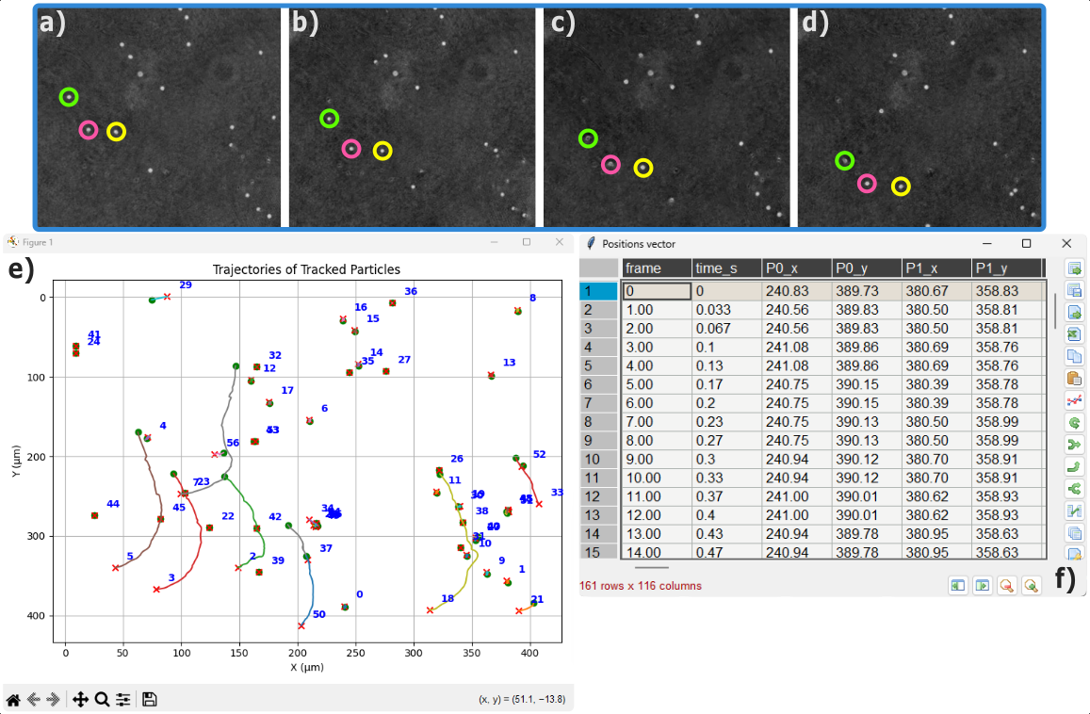

**Fig 15.** Workflow of the particle tracking process in HoloBio.

**5.1.3 Record Options**

The Record Options panel allows the user to record either holograms acquired from the digital camera or the reconstructed images (Phase or Amplitude). The same recording options are also available when working with previously recorded hologram videos. While recording is active, a red “REC” indicator appears on the panel to notify the user that the session is being captured. All recordings are saved in .mp4 format.

**How to use it?**

* Step 1 - From the Record dropdown menu, select what you wish to capture: Hologram, Phase, or Amplitude.
* Step 2 - Click Start to begin recording. A red REC message will appear to confirm that recording is active.
* Step 3 - Click Stop to end the recording session. The system will prompt you to specify a file name and storage location, after which the video will be automatically saved in MP4 format.

**5.2 Real-Time DLHM**

1. **Auxiliary Tools**

In addition to its core hologram reconstruction and visualization modules, **HoloBio** provides a dedicated set of auxiliary tools designed to support the processing and analysis of biological images. The auxiliary tools are organized into three categories:

* **Bio-Analysis** – for quantitative biological measurements and structural evaluation.
* **Filters** – for image enhancement and visualization control.
* **Speckle** – for speckle noise reduction and comparative analysis.
  1. **Bio-Analysis**

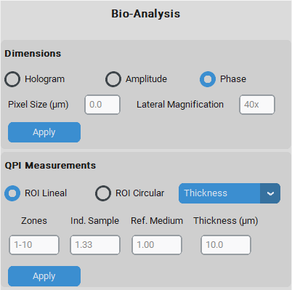The Bio-Analysis provides tools for extracting quantitative biological information from numerical reconstructions. It currently includes three functions: i) Dimensions, ii) QPI Measurements, and iii) Microstructure Metrics, as shown in **Fig. 18**.

* + 1. **Dimensions**

The Dimensions tool allows the user to obtain measurements of the physical dimension of the specimen. Select whether the measurements will be based on the Hologram, the reconstructed Amplitude, or the Phase image.

* 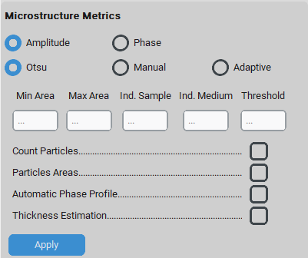**Pixel Size (µm):** Defines the dimension of the pixel size of the camera used for acquisition.
* **Lateral Magnification:** Indicates the optical magnification applied during the acquisition (e.g., 40x).

**How to use?** Step 1 – Define Parameters.

Step 2 – Adjust the Scale Bar.

Step 3 – Perform Measurements.

**Fig. 19.** illustrates the use of the Dimensions panel. In panel (a), once the pixel size and lateral magnification are defined, the Apply button updates the image scaling so that subsequent analyses are expressed in real-world units. By default, a scale bar is displayed on the image. This bar can be modified in two ways: by left-clicking, the user may adjust its length (panel b, right), and by right-clicking, the user can change its color (available options: white, black, or red; panel b, left). After applying the dimensions, users can draw lines between two points in the image to measure distances within the sample. Panel (d) shows examples of measured cell diameters, while panel (c) presents zoomed views of two selected regions to highlight the computed values.

**Fig. 18.** Bio-Analysis panel of the HoloBio interface.

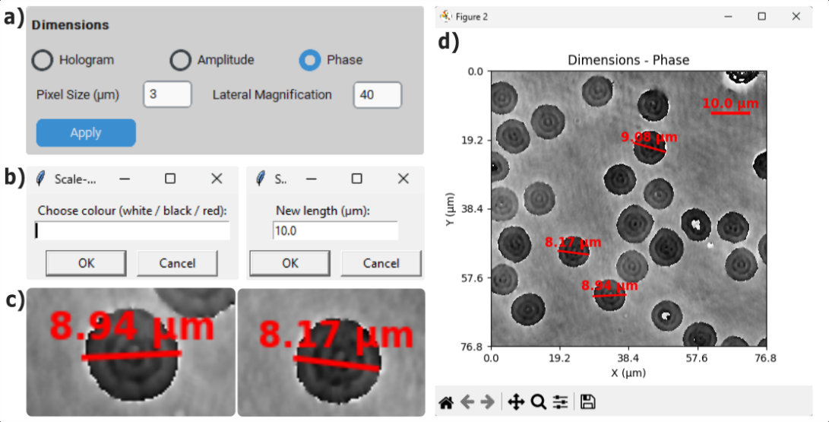

**Fig 19.** Workflow of the Dimensions tool in HoloBio. (a) shows the selection of the measurement mode and magnification parameters. (b) illustrates the scaling options for color and reference length. (c) displays examples of individual particle size measurements. (d) presents the resulting dimension annotations over the reconstructed phase image.

* + 1. **QPI Measurements**

The QPI (Quantitative Phase Imaging) Measurements section allows users to extract phase profiles, perform thickness or refractive index–based analyses within a selected Region of Interest (ROI).

* **ROI Selection:** Allows the user to select the geometry of the measurement region, either Lineal or Circular, which determines how the phase profile will be extracted for quantitative analysis.
* **Measurement Mode:** Specifies the type of quantity the user wants to evaluate. Two options are available (Thickness and Refractive Index).
* **Input Parameters:** The active fields depend on the selected *Measurement Mode.*
* If Thickness is selected → the fields **Ind. Sample** (refractive index of the sample) and **Ref. Medium** (refractive index of the surrounding medium) becomes available.
* If Refractive Index is selected → the field **Thickness** is enabled to provide the sample thickness.
* Zones are always available to define the range of regions to be analyzed.

By clicking Apply, the system computes and displays the selected measurement, enabling quantitative analysis of biological specimens.

**How to use?** Step 1 – Define ROI.

Step 2 – Select Measurement Mode.

Step 3 – Enter Input parameters.

Step 4 – Perform Measurements.

**Fig 20.** illustrates the use of the QPI Measurements panel. In panel (a), the user selects the ROI geometry (linear or circular), chooses the measurement mode (e.g., thickness), and defines the required input parameters such as Ind. Sample, Ref. Medium. Once the parameters are set, pressing Apply enables the extraction of quantitative phase information. Panel (c) shows how users can define line profiles by selecting two points within the image. Each profile corresponds to a region of the sample where the phase variation will be analyzed. The resulting phase profiles are plotted in panel (d), displaying the phase distribution as a function of distance for the selected ROIs. Finally, panel (b) presents the QPI results table, which summarizes key numerical values for each zone, including minimum, maximum, and average phase.

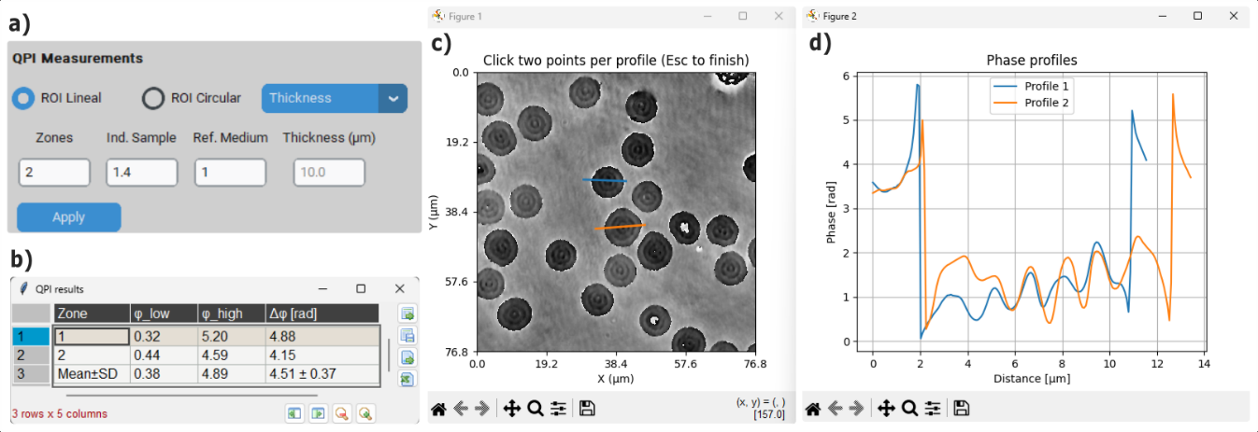

**Fig. 20.** Use of the QPI Measurements panel in HoloBio. (a) shows the selection of ROI geometry, measurement mode, and input parameters. (b) presents the QPI results table summarizing numerical values, including minimum, maximum, and average phase for each zone. (c) illustrates the definition of line profiles on the sample image for phase analysis. The corresponding phase distributions as a function of distance are plotted in (d).

* + 1. **Microstructure Metrics**

The Microstructure Metrics section allows users to quantify structural features from amplitude or phase reconstructions by segmenting the sample and applying specific measurements.

* **Input Image Selection:** The user can choose whether the analysis will be performed on the Amplitude or the Phase image.
* **Segmentation Mode:** Three segmentation options are available:
  + **Otsu:** Automatically determines the threshold based on image statistics.
  + **Manual:** Requires the user to input a threshold value.
  + **Adaptive:** Applies a locally adaptive thresholding method.
* **Input Parameters:** 
  + **Min Area / Max Area:** Define the minimum and maximum particle size to be considered during analysis.
  + **Ind. Sample / Ind. Medium:** Optional fields for entering the refractive indices of the sample and the surrounding medium, used in thickness estimation.
  + **Threshold:** Manually entered value when the *Manual* segmentation mode is selected.
* **Measurement Options:**
  + **Count Particles:** Computes the number of detected particles.
  + **Particles Areas:** Calculates the area of each segmented particle.
  + **Automatic Phase Profile:** Extracts phase profiles for each detected region.
  + **Thickness Estimation:** Provides an estimation of thickness based on phase information and input refractive indices.

By clicking Apply, the system executes the selected analysis and displays the corresponding results, enabling a detailed quantitative characterization of microstructures.

**iii – a. Count Particles**

When the user selects **Count Particles** and clicks **Apply**, the system automatically initiates a sequence of steps for particle detection. The workflow is illustrated in Fig. 21. Panel (a) displays the Histogram with Threshold, where the selected segmentation method (e.g., Otsu) determines the threshold line used for binarization. Panel (b) shows the Binarized Image, in which objects appear in black or white depending on the thresholding result. Next, a Sample Polarity Dialog (panel c) asks the user to confirm whether the particles of interest are represented as white (w) or black (b), ensuring correct interpretation of the mask. Once polarity is confirmed, the system generates the Connected Components view (panel d, left), where each detected particle is color-coded and assigned a unique label. The Detected Samples Visualization (panel d, right) overlays red contours, IDs, and centroids onto valid particles, showing only those that meet the user-defined constraints (e.g., minimum and maximum area). Finally, a Detection Summary window (panel e) provides numerical information, including the threshold value, number of detected particles, and the count of particles that fall within the specified area range.

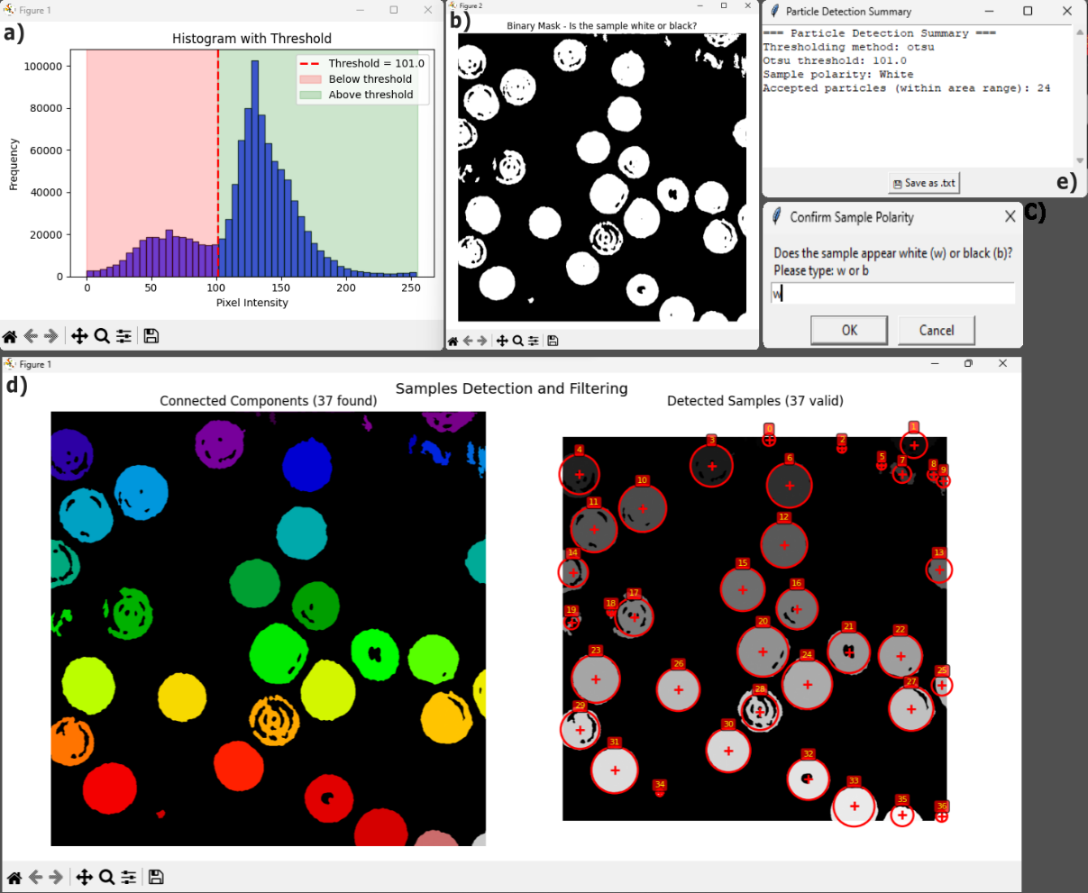

**Fig. 21.** Workflow of the particle detection module in HoloBio. (a) shows the histogram with threshold used for binarization. (c) presents the binarized image, while (c) illustrates the sample polarity confirmation dialog. (d, left) displays the connected components view with color-coded labels, and (d, right) shows the detected samples visualization with contours, IDs, and centroids of valid particles. Finally, (e) provides the detection summary with numerical results including threshold value and particle counts.

**iii – b. Particles Areas:**

When the user selects **Particles Areas** and clicks **Apply**, the system automatically launches a workflow for calculating the size of each detected particle. The process is illustrated in **Fig. 22**. Panel (a) displays the Binarized Image, where objects appear in black or white depending on the chosen segmentation method and polarity. Once the polarity is confirmed, the system generates the Connected Components view (panel b, left), in which each detected particle is color-coded and labeled, and the Detected Samples Visualization (panel b, right), where valid particles are highlighted with red contours, IDs, and centroid markers. Panel (c) shows the Distribution of Particle Areas, represented as a histogram that summarizes the frequency of occurrence for different particle sizes. Panel (d) presents the Particle Data Table, listing for each particle its ID, centroid coordinates (X, Y), measured area (in µm²), and estimated diameter. Finally, as part of the workflow, a Sample Polarity Dialog (panel e) ensures correct interpretation by asking the user to specify whether the objects of interest are represented as white (w) or black (b).

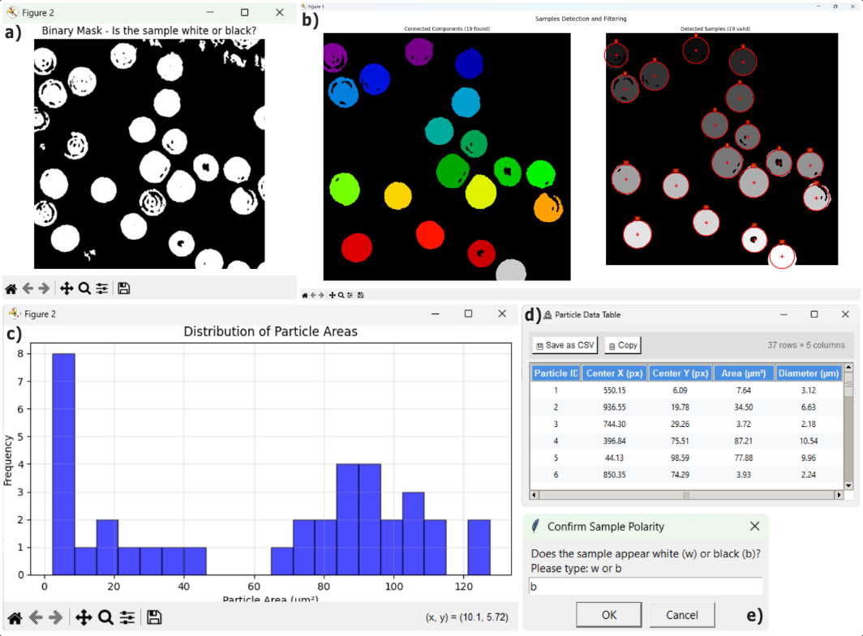

**Fig. 22.** Particle analysis workflow in HoloBio. (a) shows the binarized image generated after thresholding and polarity selection. (b, left) presents the connected components view with color-coded labels, and (b, right) displays the detected samples visualization with contours, IDs, and centroids of valid particles. (c) illustrates the distribution of particle areas as a histogram. (d) shows the particle data table with centroid coordinates, area, and diameter values. (e) depicts the sample polarity dialog for confirming correct interpretation of the mask.

**iii – c. Automatic Phase Profile:**

When **Automatic Phase Profile** is selected and the user clicks **Apply**, HoloBio runs a fully automated routine to extract phase profiles across each valid particle and to estimate the phase shift Δφ per sample. The sequence is shown in Fig. 23. (a) Binary Mask. The input phase image is thresholded using the chosen segmentation method (Otsu, Manual, or Adaptive). A polarity dialog prompts the user to confirm whether the objects of interest correspond to white regions on a dark background or vice versa, ensuring correct interpretation. (b) Valid Profile Lines. For every particle detected, the algorithm searches for a suitable line passing through the object that connects background regions on both sides without intersecting other particles. These lines (shown in color) represent the sampling geometry used to compute phase differences. White circles mark the detected particles. (c) Phase Shift Summary. For each valid profile, the system computes the phase-shift Δφ as the difference between plateau regions across the line. A summary window lists all valid samples and their respective Δφ values in radians. (d) Connected Components and Filtering. The left panel displays the labeled connected components found in the mask, each color-coded for visualization. The right panel shows the detected and validated samples, highlighted with red circles, centroids, and IDs. Only particles meeting the size criteria (Min/Max Area) and yielding valid profiles are retained for analysis

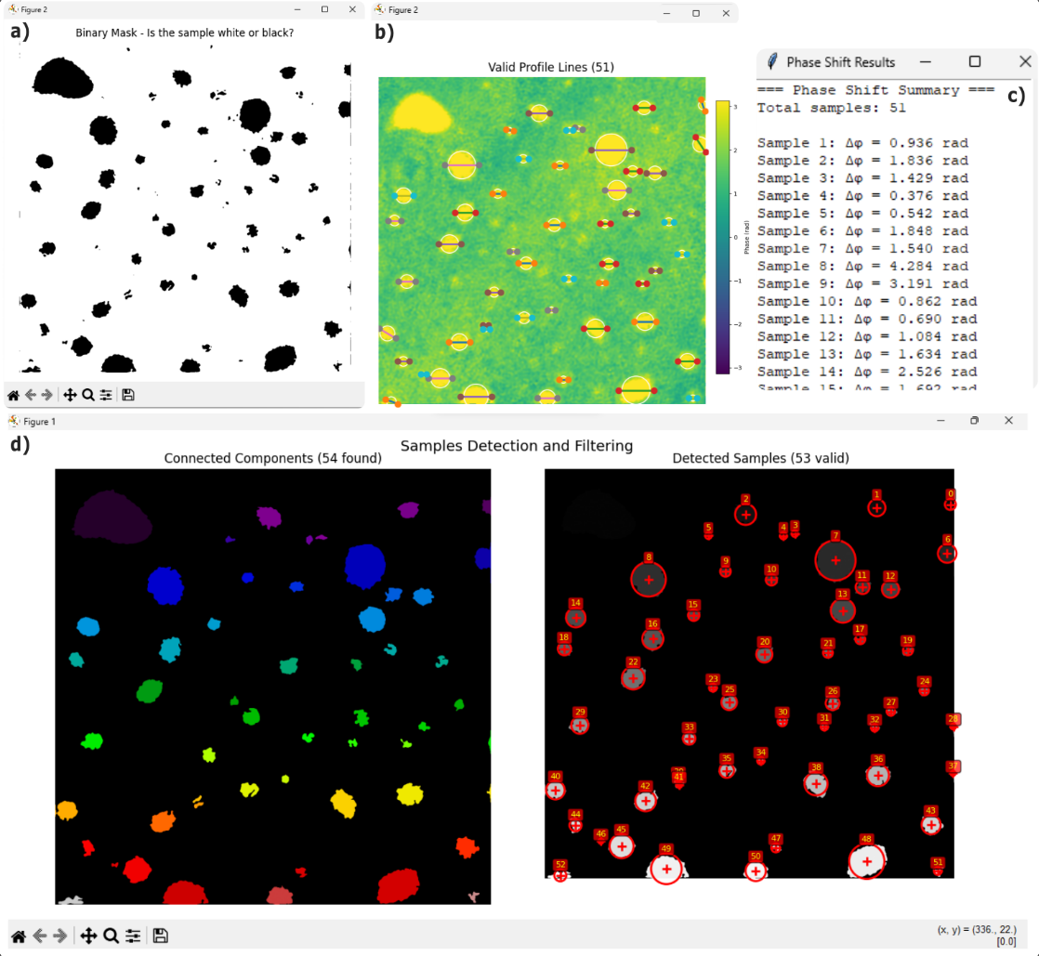

**Fig. 23.** Automatic phase profile workflow in HoloBio. (a) Binary mask generated after thresholding and polarity confirmation. (b) Valid profile lines placed across particles with fitted circles. (c) Phase-shift summary window listing Δφ values for each sample. (d, left) Connected components view; (d, right) final detected samples with IDs, centroids, and validation contours.

**iii – d. Thickness Estimation:**

When the user selects **Thickness Estimation** and clicks **Apply**, the system automatically initiates a workflow to calculate the optical thickness of each detected particle. The procedure is illustrated in **Fig. 24.** Panel (a) shows the Binarized Image, generated according to the selected segmentation method and polarity, where particles are separated from the background. Once polarity is confirmed (panel d), the algorithm computes the Delta Phase (Δφ) Map, displayed in panel (b), which represents the phase difference between the sample and the surrounding medium. From this phase information, the software derives the Estimated Thickness Map (panel c), where the optical thickness of each particle is calculated in micrometers based on the input refractive indices provided by the user. The resulting thickness values are displayed with a color scale, enabling both qualitative visualization and quantitative estimation of microstructural properties.

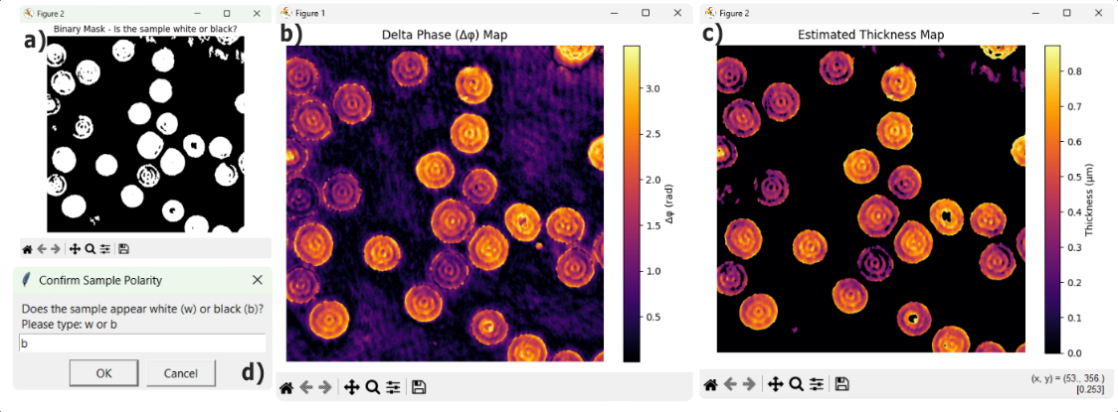

**Fig. 24.** Thickness estimation workflow in HoloBio. (a) shows the binarized image used to separate particles from the background. (b) displays the Δφ (Delta Phase) map, representing the phase difference between the sample and the surrounding medium. From this information, the software generates the estimated thickness map (c), where the optical thickness of each particle is calculated and displayed in micrometers using a color scale. (d) illustrates the polarity confirmation dialog.

**How to use it?**

Step 1 - Select the input image (Amplitude or Phase).

Step 2 - Choose the segmentation mode (Otsu, Manual, or Adaptive).

Step 3 - Define the input parameters (area range, indices, threshold if required).

Step 4 - Select the desired measurement options.

Step 5 - Click Apply to perform the analysis and obtain the results**.**

* 1. **Filters**

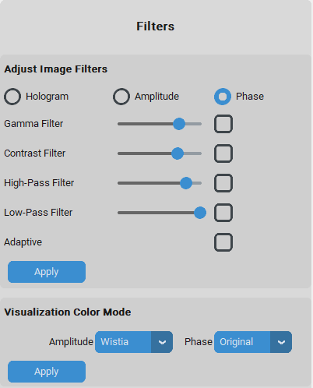

Figure XX. xxxxxxxxx xxxxxxxxxxxxxxxxxxxxxxxxxxxxx.

**Fig 25.** HoloBio Filters panel showing image adjustment tools (gamma, contrast, high/low-pass, adaptive) and color visualization settings.

The Filters provides tools for enhancing images (Holograms, Amplitude or Phase) through spatial and intensity-based filtering. It currently includes two functions: Adjust Image Filters and Visualization Color Mode (Fig 15).

* + 1. **Adjust Image Filters**

The Adjust Image Filters tool allows the user to apply different filtering techniques. These filters are intended to improve visibility and highlight structural details.

* **Gamma Filter:** Controls the value of γ (gamma), which adjusts the relationship between dark and bright intensities in the image.

The applied equation is:

$I_{Out}=255 × {\left(\frac{I}{I_{Max}}\right)}^{γ}$,

where, *I* is the pixel intensity of the original image, *IMax* is the maximum intensity (for normalization), and *Iout* is the corrected pixel value.

* If γ > 1 → the image becomes brighter (output intensities are expanded).
* If γ < 1 → the image becomes darker (output intensities are compressed).
* **Contrast Filter:** Controls contrast factor *CT*, stretching or compressing pixel values around the mean intensity.

The applied equation is:

$I_{Out}=\left(I- μ\right) ×CT+μ$,

where *I* is the pixel intensity, *μ* is the mean intensity of the original image, *CT* is the slider value, and *Iout* is the adjusted intensity.

* **High-Pass Filter:** Controls the cutoff radius of a circular mask in the Fourier domain. Low-frequency components (smooth background variations) are suppressed, while high-frequency components (edges and fine details) are preserved. Increasing the cutoff radius allows more high frequencies to pass through, enhancing details but potentially amplifying noise.
* **Low-Pass Filter:** Controls the cutoff radius of a circular mask in the Fourier domain. High-frequency components (fine details and noise) are suppressed, while low-frequency components (global variations) are preserved. Reducing the cutoff radius smooths the image and improves clarity, but may also remove fine structural information.
* **Adaptive:** Controls the histogram equalization to redistribute pixel intensities across the available dynamic range, enhancing contrast in saturated or low-contrast regions.The applied equation is:

$I_{out}=I_{min}{+\left(I_{max}{-I_{min} }\right)} CDF \left( \frac{I_{in}-I_{min}}{I_{max}-I_{min}}\right)$,

where $I_{in}$ is the input pixel intensity, $I_{min}$ ​ and $I_{max}$ ​ are the minimum and maximum intensities of the image, $CDF$ is the cumulative distribution function of the normalized histogram, and $I_{out}$ ​ is the adjusted pixel intensity. This transformation expands densely populated intensity ranges (increasing local contrast) and compresses less populated ones, while preserving the relative order of intensities.

**How to use it?**

Step 1 – Select the image type (Hologram, Amplitude, or Phase).  
Step 2 – Adjust the desired filters using the sliders and checkboxes.  
Step 3 – Click Apply to visualize the filtered result.

* + 1. **Visualization Color mode**

The Visualization Color Mode tool allows the user to change the color representation of the reconstructed Amplitude and Phase images. Several visualization modes are available, including Original, Viridis, Plasma, Inferno, Magma, Cividis, Hot, Cool, Wistia.

**How to use it?**

Step 1 – Select the visualization mode for Amplitude and/or Phase from the dropdown menu.  
Step 2 – Click Apply to update the display with the chosen color scheme.

**Fig. 26.** illustrates the use of the Adjust Image Filters and Visualization Color Mode panels. In panel (a), the user can apply different filters such as Gamma, Contrast, High-Pass, or Low-Pass to enhance amplitude or phase images, while panel (b) provides options to select colormaps for amplitude and phase visualization. Panel (c) shows the original phase image without modifications, panel (d) demonstrates the effect of applying a High-Pass Filter combined with the *Magma* colormap, panel (e) presents the phase visualization without filters but using the *Magma* colormap, and panel (f) illustrates the amplitude visualization displayed with the *Inferno* colormap.

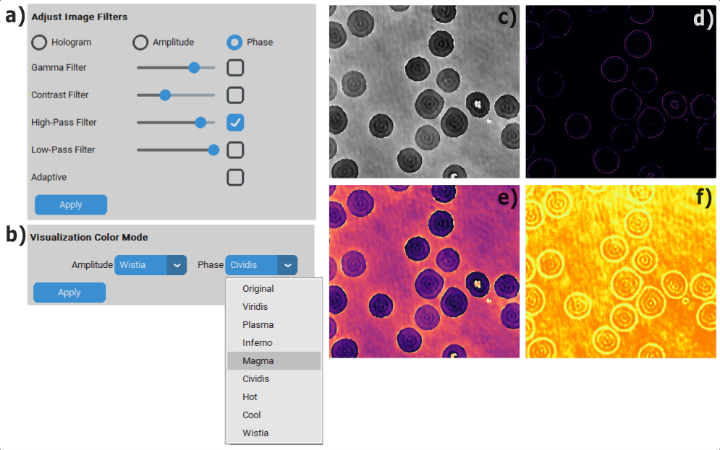

**Fig. 26.** Demonstration of the combined use of the Adjust Image Filters (a) and Visualization Color Mode (b) panels in HoloBio. (c) shows the original phase image. (d) illustrates the application of a High-Pass Filter with the Magma colormap. (e) presents the phase visualization without filters but using the Magma colormap, and (f) displays the amplitude visualization with the Inferno colormap.

* 1. **Speckle**

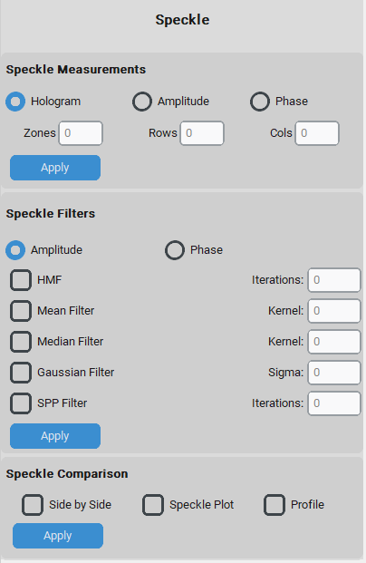The Speckle provides tools for measuring and reducing speckle noise in reconstructed images, both in amplitude and phase. In addition, it includes a set of comparison tools that allow users to evaluate the effectiveness of different speckle reduction methods (Fig 17).

Ilustración . Xxxxxx xxxxxxx .

**Fig. 27.** Tools for speckle analysis and reduction, including filtering methods and comparison utilities.

* + 1. **Speckle Measurements**

The Speckle Measurements tool allows users to quantify speckle contrasts (*C*) in images. The measurement is performed using the expression

$C=\frac{σ}{\overline{I}}$,

where σ is the standard deviation and $\overline{I}$ represents the mean intensity, both calculated within the selected ROI. Measurements can be performed on the Hologram, Amplitude, or Phase reconstructions.

* **Zones:** Defines the number of independent regions where speckle contrast will be computed. Each zone provides a separate measurement.
* **Rows:** Specifies how many horizontal divisions will be applied within the selected ROI, subdividing it into smaller analysis areas.
* **Cols:** Specifies how many vertical divisions will be applied within the selected ROI, further partitioning the image into multiple zones.

**How to use it?**

Step 1 – Select the image type (Hologram, Amplitude, or Phase).

Step 2 - Enter the number of Zones, Rows, and Columns to partition the selected Region of Interest (ROI).

Step 3 –Draw one or more ROIs where speckle will be analyzed.

Step 4 – Click Apply to calculate the speckle contrast for each zone.

Step 5 - The system displays the speckle values in a results table, including minimum, maximum, and average contrast.

**Fig. 28.** illustrates the use of the Speckle Measurements tool. In panel (a), the user selects the image type for analysis (Hologram, Amplitude, or Phase) and defines the number of Zones, Rows, and Columns to partition the selected Regions of Interest (ROIs). Once the parameters are entered, pressing Apply activates the speckle computation. Panel (c) shows how the user can draw one or more ROIs on the image. Each ROI is subdivided according to the number of rows and columns defined, generating multiple zones for speckle analysis. The red labels (1–8) illustrate the partitioning of the selected regions. Panel (b) presents the Speckle Results table, which summarizes the calculated speckle contrast values for each zone, as well as the overall average. These results allow users to quantitatively compare the speckle level in different parts of the image and evaluate the impact of speckle reduction techniques.

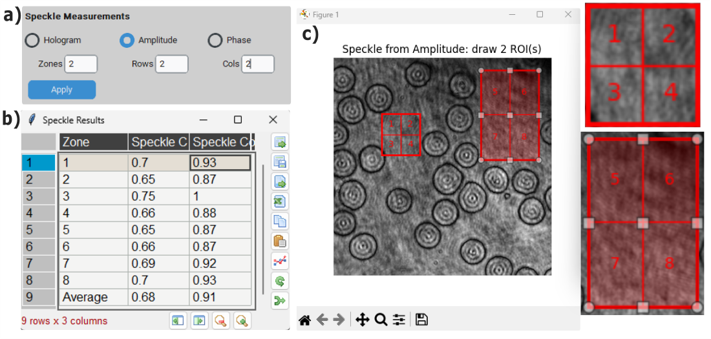

**Fig 28.** Speckle Measurements workflow in HoloBio. (a) shows the selection of image type (hologram, amplitude, or phase) and the definition of zones, rows, and columns for partitioning the regions of interest (ROIs). (b) presents the results table, reporting speckle contrast values for each zone and the overall average. (c) illustrates the ROI selection and subdivision into multiple zones (1–8) for speckle analysis.

* + 1. **Speckle Filters**
    2. **Speckle Comparison**

1. **Appendix**